1. Go to google drive and click on New
2. Select More from the drop down
3. Click Google App Scripts
4. 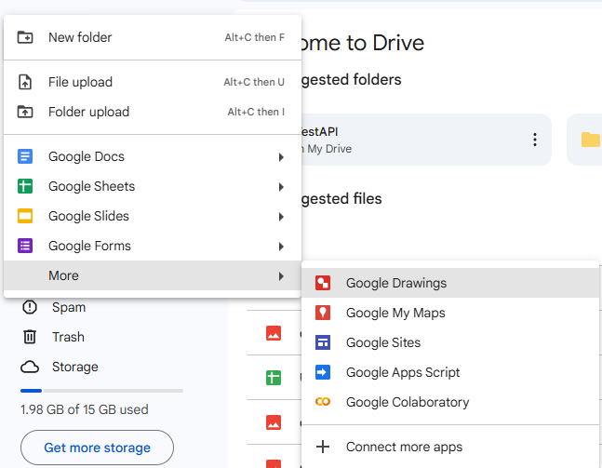Paste the following code and add your drive folder id and sheets id respectively.

function doPost(e) {

  try {

    var folderId = "xxx-xxxx";  // Change this

    var sheetId = "xx_xxxxx";  // Change this

    var folder = DriveApp.getFolderById(folderId);

    var sheet = SpreadsheetApp.openById(sheetId).getActiveSheet();

    var blob = Utilities.newBlob(Utilities.base64Decode(e.parameters.image), e.parameters.mimeType, e.parameters.filename);

    var file = folder.createFile(blob);

    var fileUrl = file.getUrl();

    var timestamp = new Date();

    // Append data to Google Sheet

    sheet.appendRow([e.parameters.filename, fileUrl, timestamp]);

    return ContentService.createTextOutput(JSON.stringify({ success: true, fileUrl: fileUrl }))

                         .setMimeType(ContentService.MimeType.JSON);

  } catch (error) {

    return ContentService.createTextOutput(JSON.stringify({ success: false, error: error.message }))

                         .setMimeType(ContentService.MimeType.JSON);

  }

}

1. Click **Deploy** from the top right corner and select **New Deployment**
2. Click on the **settings** button from the popup and select **Web App**

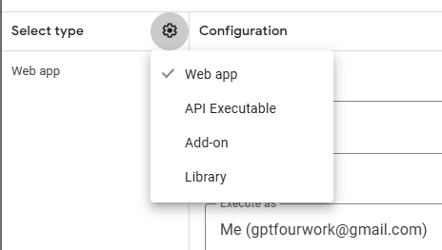

1. Select **Anyone** from the authorization access dropdown
2. Click Deploy button at the bottom and copy the script url it provides.
3. Update line 204 in **scripts.js** and paste the link you copied in step 8.

const response = await fetch("https://script.google.com/macros/s/xxxx/exec", {

                    method: "POST",

                    body: formData

                });